Boveys Down Farm
Farway, Honiton, Devon, EX24 6JD
01404 871436 or 01404 871480
info@sweetlands.co.uk
www.boveysdownfarm.co.uk/glorious-glamping

Glorious Glamping…
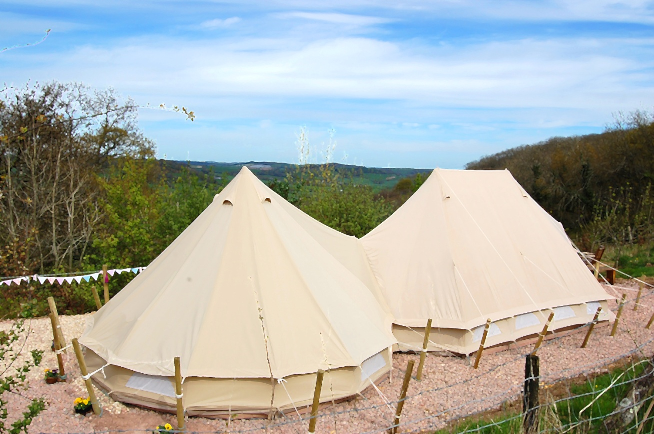
Pure indulgence awaits in Boveys Down Farm’s own ‘Ultimate Emperor’ Luxury Bell-tents. Set in a quiet spot, in the heart of East Devon AONB; with far reaching views of the picturesque Coly Valley, no expense has been spared in creating pure serenity.
Prices

- 2 nights.......................................................................... £220
- 3 nights.......................................................................... £300
- 4 nights.......................................................................... £380
- 5 nights.......................................................................... £450
- 6 nights.......................................................................... £540
- 7 nights.......................................................................... £560

(Available 1st March - 30th September)

Welcome pack, linen, towels, tea/coffee & self catering facilities are included in listed prices

