Boveys Down Farm’s Glorious Glamping

FAO Pamela Sweetland

Personal Information

Name

Address

Postcode

E-mail

Phone number

Your Requirements
Type of pitch required (delete as appropriate) | - Luxury ‘Emperor’ Bell-tents (minimum stay 2 nights)  - ‘Janet’s (onsite) Caravan* (Linen included)  - ‘Caroline’s (onsite) Caravan* (Linen included)

Date of arrival

Date of departure

Number of adults (inclusive of children over 12 years of age)

Number of Children aged over 5 years

Number of Children aged under 5 years

For legal reasons please supply the registration number of the vehicle you will be using.

Approx time of arrival (if known)?

Where did you hear about us?

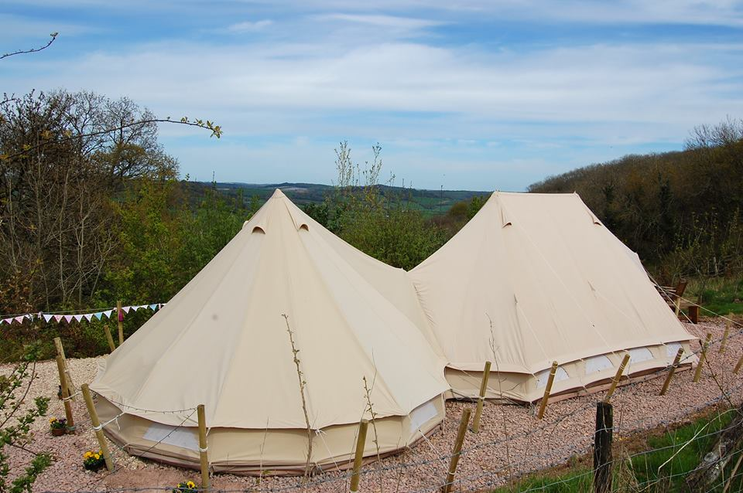

Thank you for your enquiry one of our team will be in touch shortly.

